Terraform task – 4

1). Execute the script shown in the video.
A) Terraform version constraints: They tell Terraform which provider version is allowed.
For example:
terraform {
required_providers {
aws = {
source = "hashicorp/aws"
version = "~> 6.0"
}
}
}
Here version controls which AWS provider version Terraform can use.

Meaning of each operator
Operator | Meaning | Example | Allows
= | Exactly this version | = 6.0.0 | Only 6.0.0
!= | Not this version | != 6.0.0 | Everything except 6.0.0
> | Greater than | > 6.0.0 | 6.0.1, 6.1.0, 7.0.0...
< | Less than | < 6.0.0 | 5.x.x, etc.
>= | Greater than or equal | >= 6.0.0 | 6.0.0 and newer
<= | Less than or equal | <= 6.0.0 | 6.0.0 and older
~> | Pessimistic constraint | ~> 6.0 | 6.x, but not 7.x

Example Version = “2.9.0”

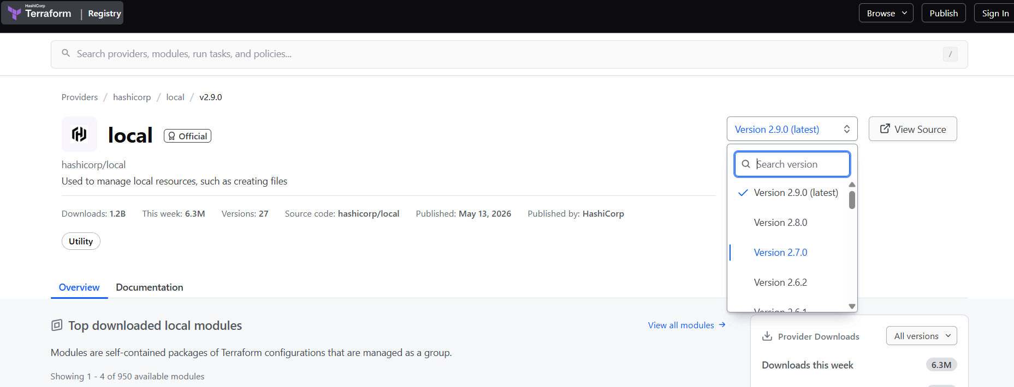

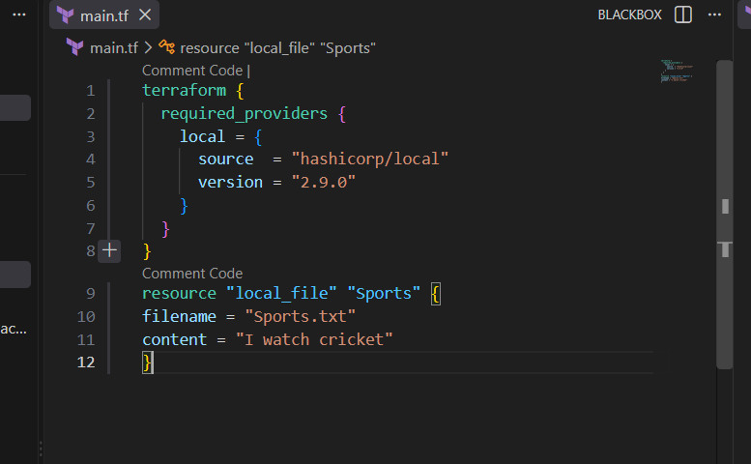
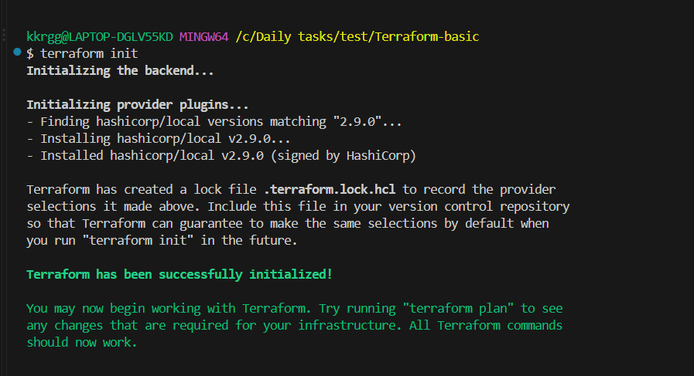

Example version = “!=2.9.0”
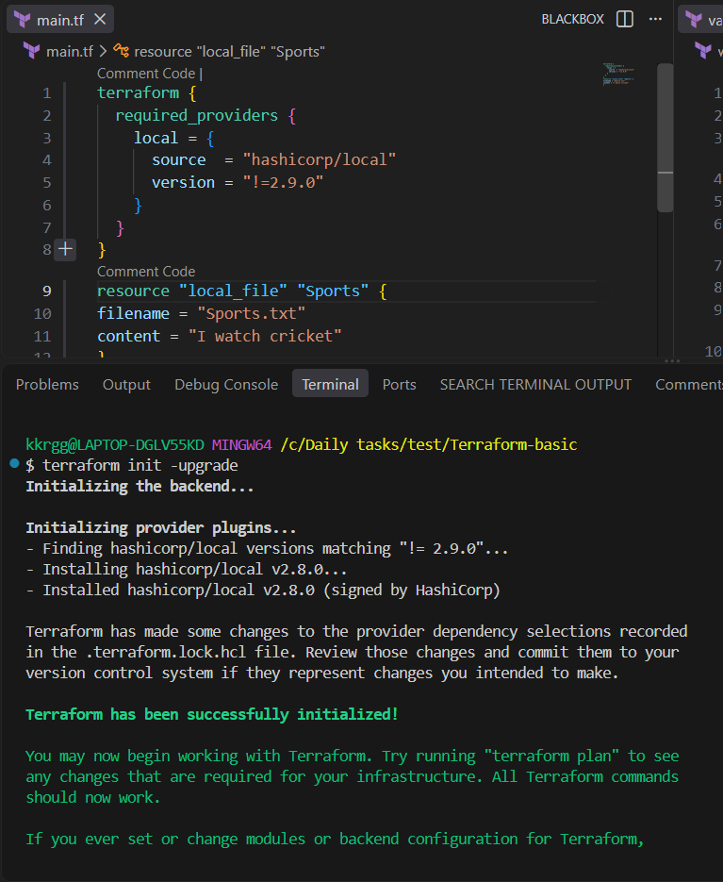

Example version = “< 2.9.0”
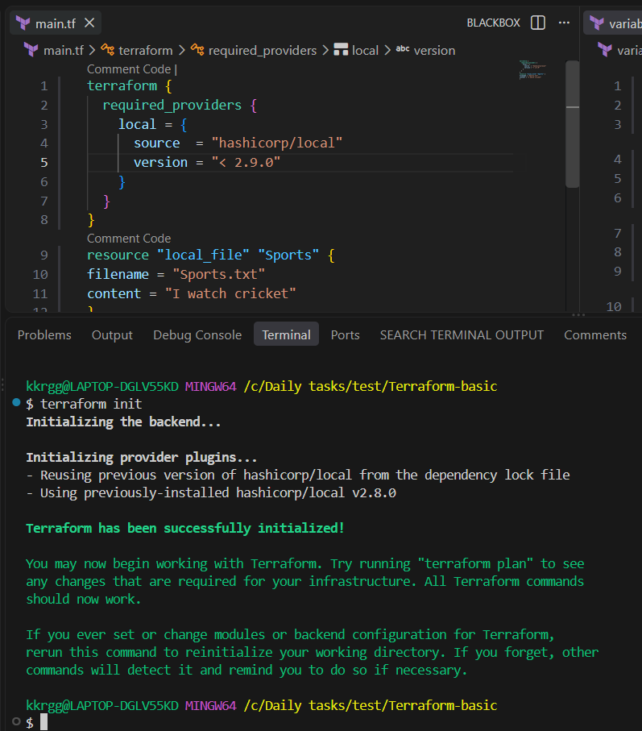

Example version = “> 2.6.2”
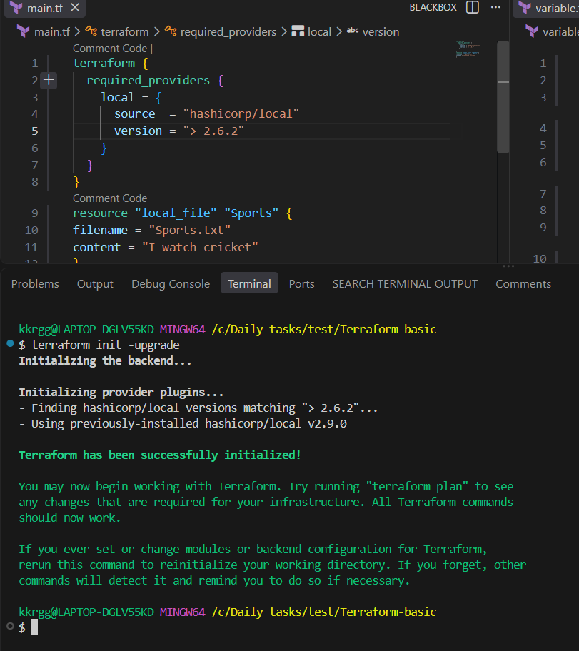

Example version = “~> 2.9.0”
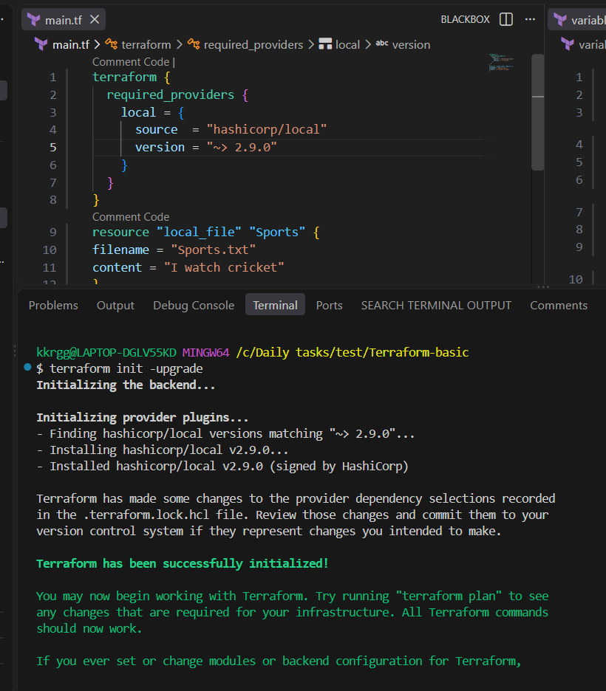

B) Data Sources

Terraform Data Sources
A data source in Terraform is used to read or retrieve information about something that already exists.
The key difference is:
Resource → creates/manages something
Data source → reads something

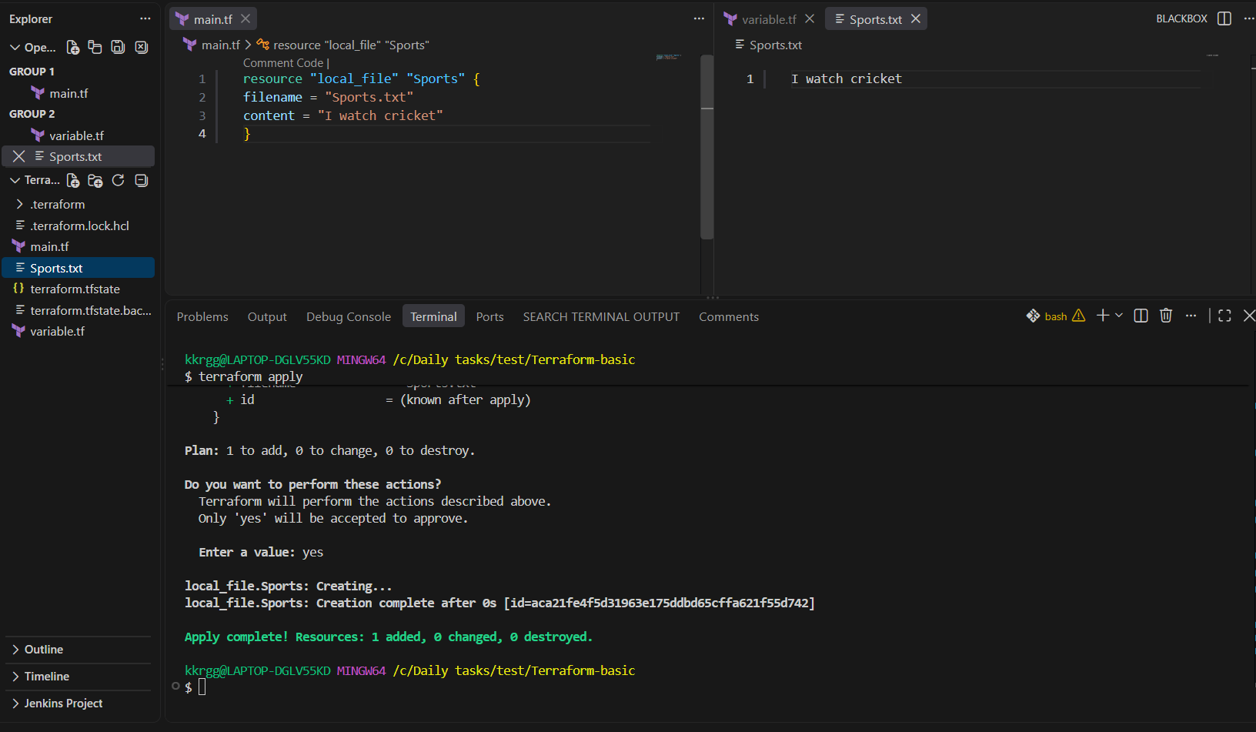
Creating new filename as Movies.txt
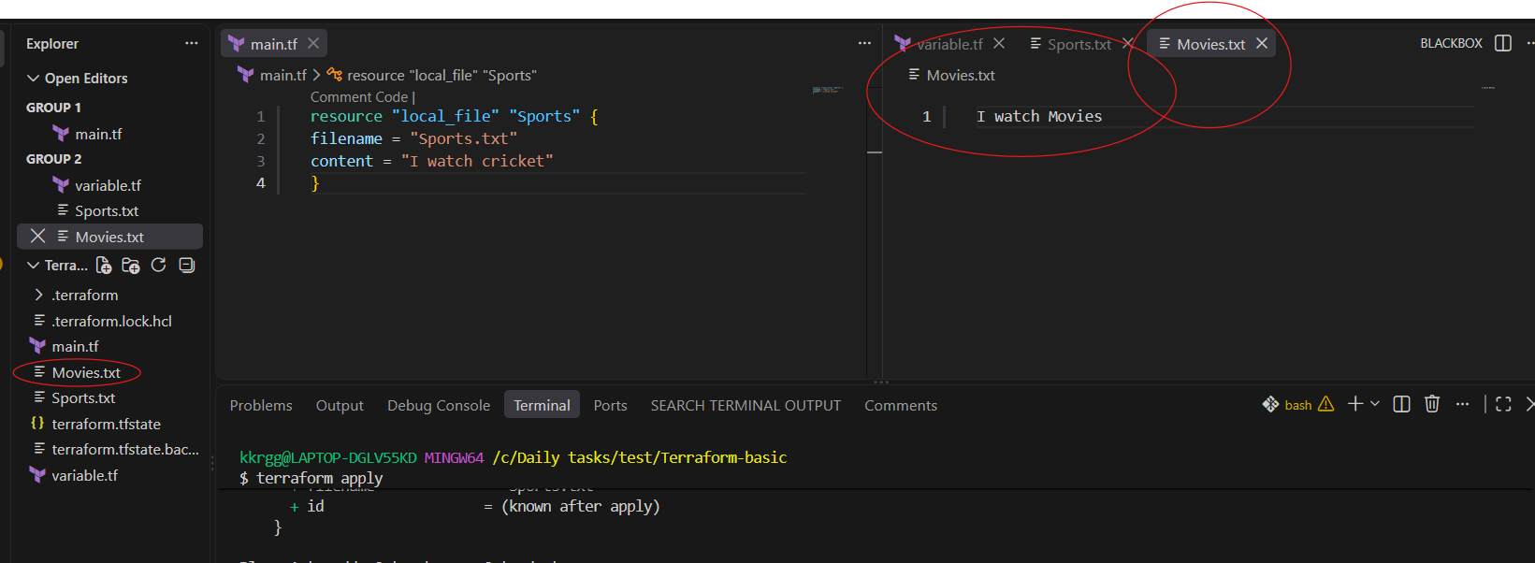

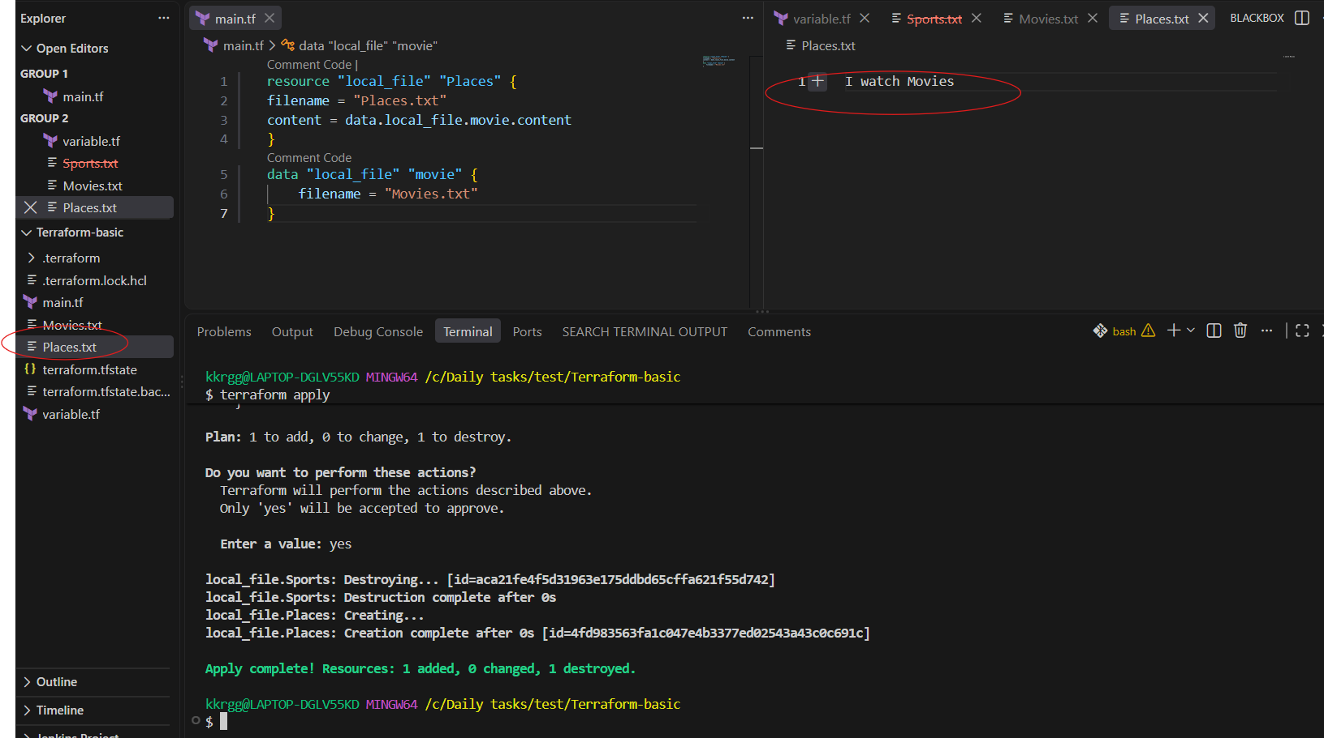

What happens here?
There are two blocks:

1. Data source
data "local_file" "movie" {
filename = "Movies.txt"
}
This says:
"Terraform, go and read the existing Movies.txt file and give me its information."
It does not create Movies.txt.
Terraform reads:
Movies.txt
↓
"I watch Movies"
You can access the content using:
data.local_file.movie.content

2. Resource
resource "local_file" "Places" {
filename = "Places.txt"
content = data.local_file.movie.content
}
This says:
"Create a new file called Places.txt, and put the content that we got from the data source into it."
So the flow is:
Existing file
Movies.txt
│
│ data source reads it
↓
data.local_file.movie.content
│
│ resource uses the content
↓
Places.txt
Therefore:
Movies.txt
------------
I watch Movies

↓ Terraform data source

Places.txt
------------
I watch Movies

Why is this called a Data Source?
Because Terraform is reading existing information:
data "local_file" "movie"
It isn't creating the Movies.txt file.

C) Meta Arguments
count and for_each are Terraform meta-arguments used when you want to create multiple instances of the same resource.
Think:
Without count/for_each
↓
1 resource

With count/for_each
↓
Multiple resources

1. count
count creates multiple copies of a resource based on a number.

Example
resource "local_file" "movie" {
count = 3
filename = "Movie-${count.index}.txt"
content = "I like Movies"
}
Run:
terraform apply
Terraform creates:
Movie-0.txt
Movie-1.txt
Movie-2.txt

What is count.index?
count.index gives the index of each instance.
count = 3

count.index
↓
0
1
2
So:
filename = "Movie-${count.index}.txt"
becomes:
Movie-0.txt
Movie-1.txt
Movie-2.txt
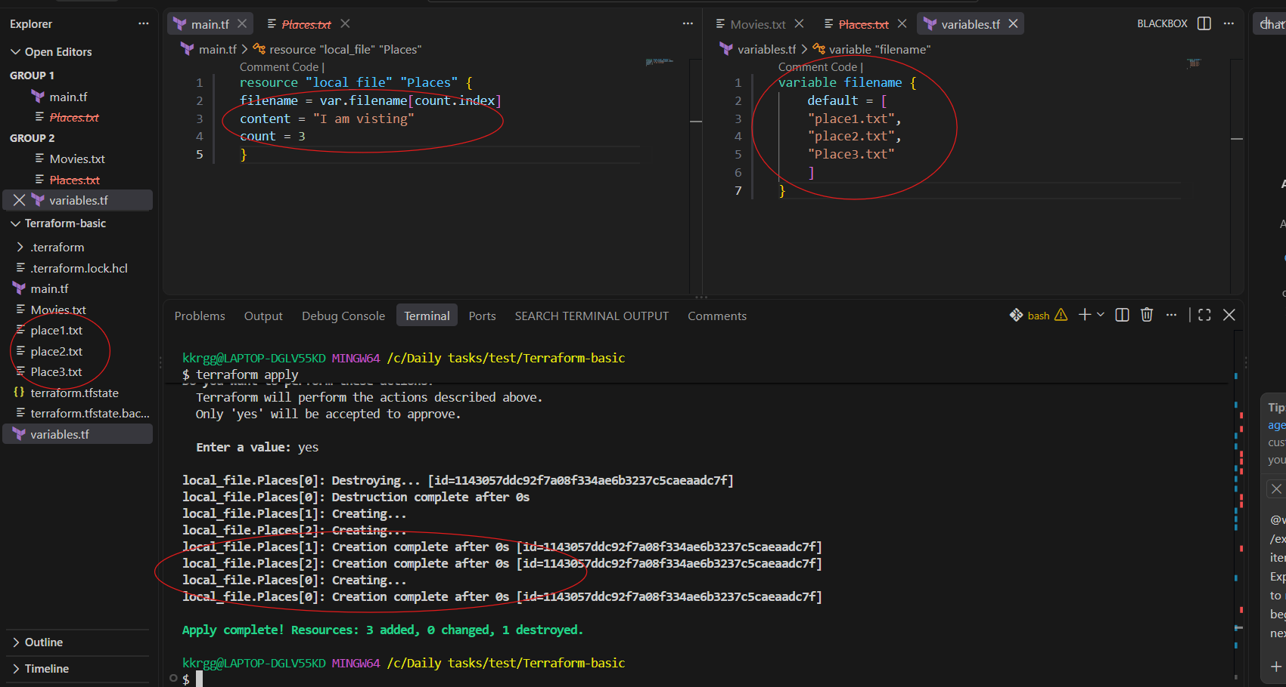

2. for_each
for_each creates multiple resources based on a set or map.
For example:
variable "files" {
default = [
"Movies.txt",
"Sports.txt",
"Places.txt"
]
}
You can use:
resource "local_file" "example" {
for_each = toset(var.files)

filename = each.value
content = "This is a file"
}
Terraform creates:
Movies.txt
Sports.txt
Places.txt

each.key and each.value
With for_each:
each.key
each.value
are available.
For a set like:
Movies.txt
Sports.txt
Places.txt
the value is:
each.value

Example : For_each
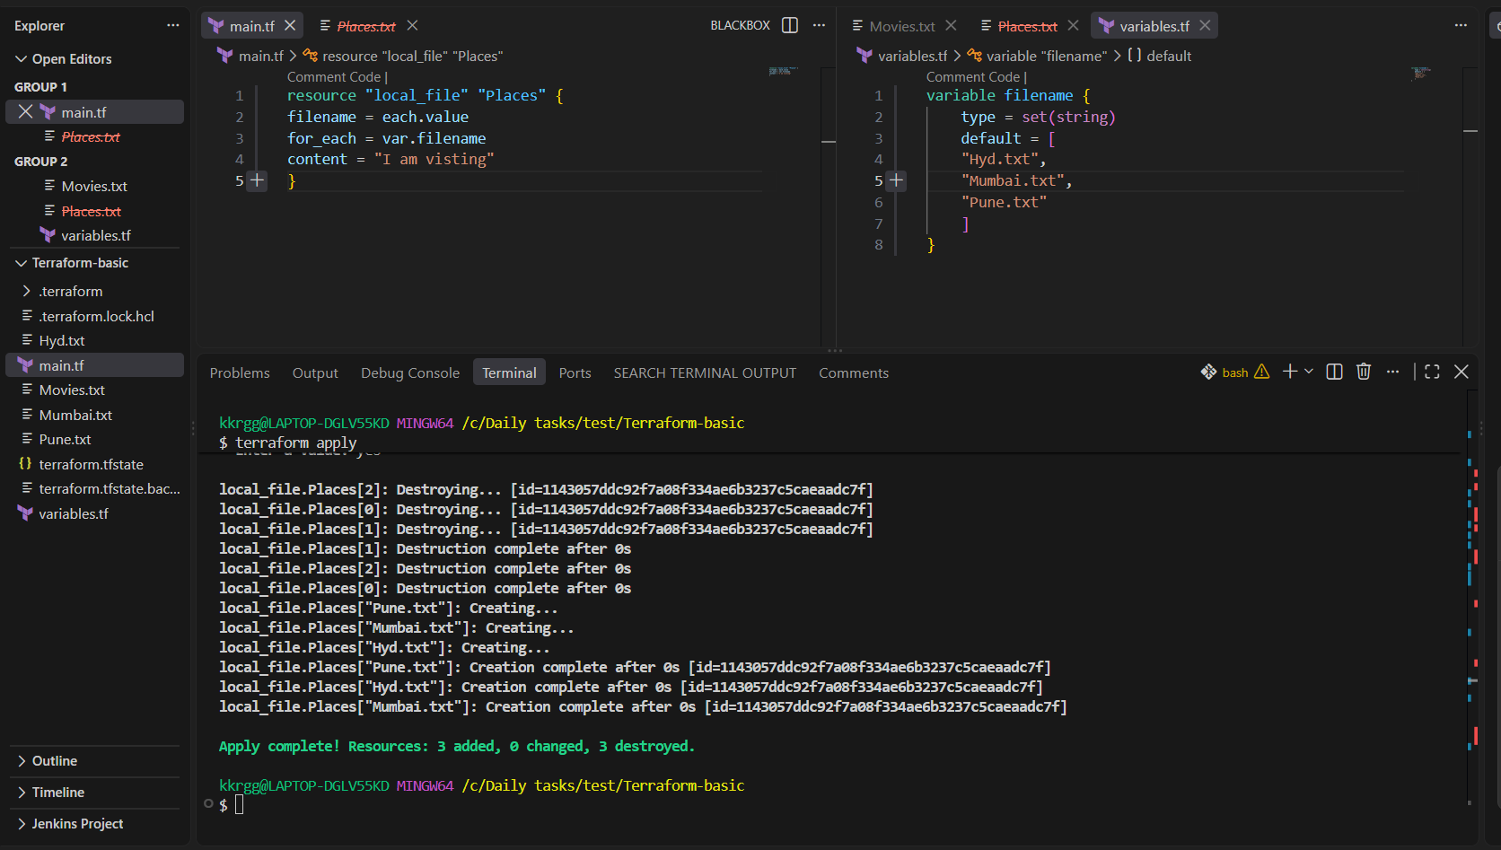

D) Creating AWS resources
create the IAM user in aws
main.tf
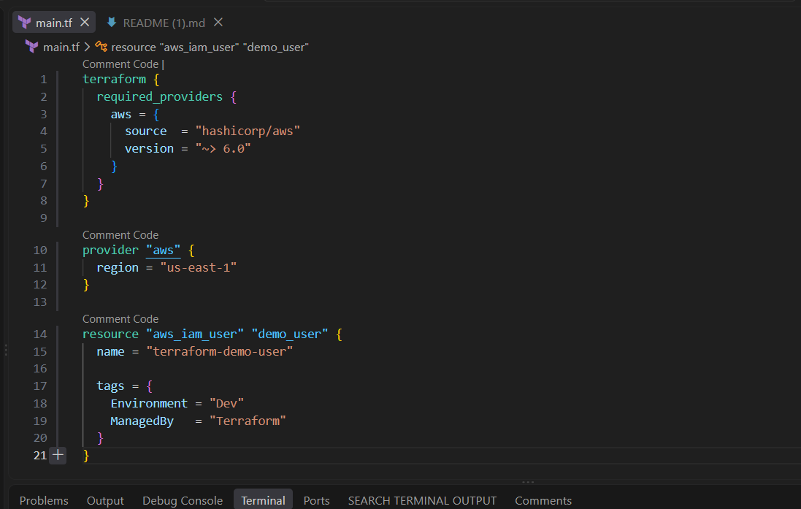

Step 1: Configure AWS credentials
First make sure the AWS CLI is installed:
aws --version
Then run:
aws configure
AWS asks:
AWS Access Key ID [None]: <your-access-key>
AWS Secret Access Key [None]: <your-secret-key>
Default region name [None]: us-east-1
Default output format [None]: json
Enter your AWS credentials.
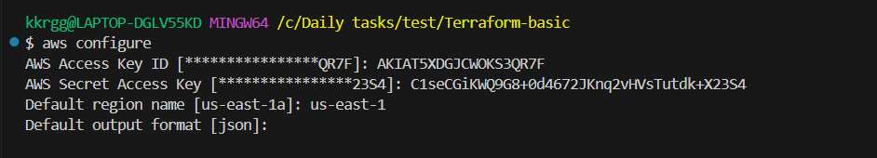
This creates/configures AWS CLI credentials, normally under:
~/.aws/credentials
~/.aws/config
Terraform's AWS provider can use these credentials.

Run Terraform
Put main.tf in a directory:
terraform-iam-user/
└── main.tf
Then:
terraform init
Terraform downloads the AWS provider.
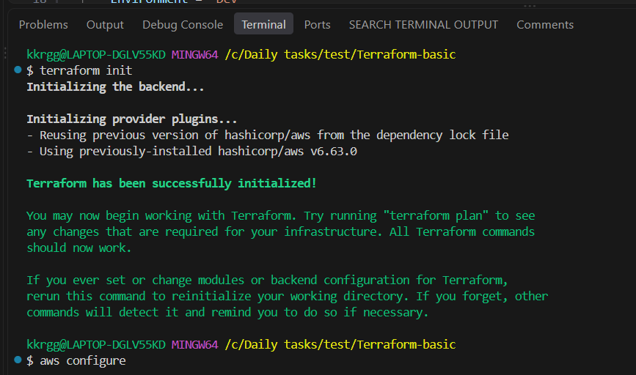
Next:
terraform validate
You should get:
Success! The configuration is valid.
Then:
terraform plan
Terraform shows something similar to:
# aws_iam_user.test_user will be created

+ resource "aws_iam_user" "test_user" {
+ name = "terraform-test-user"
}
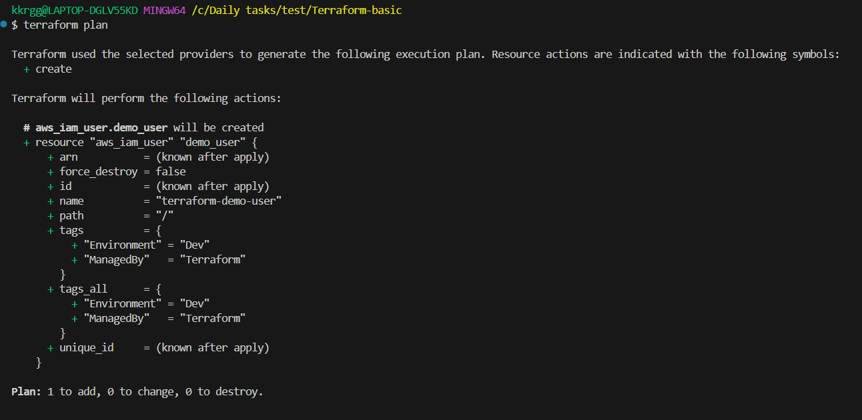
Finally:
terraform apply
Terraform asks:
Do you want to perform these actions?
Enter a value:
Enter:
Yes
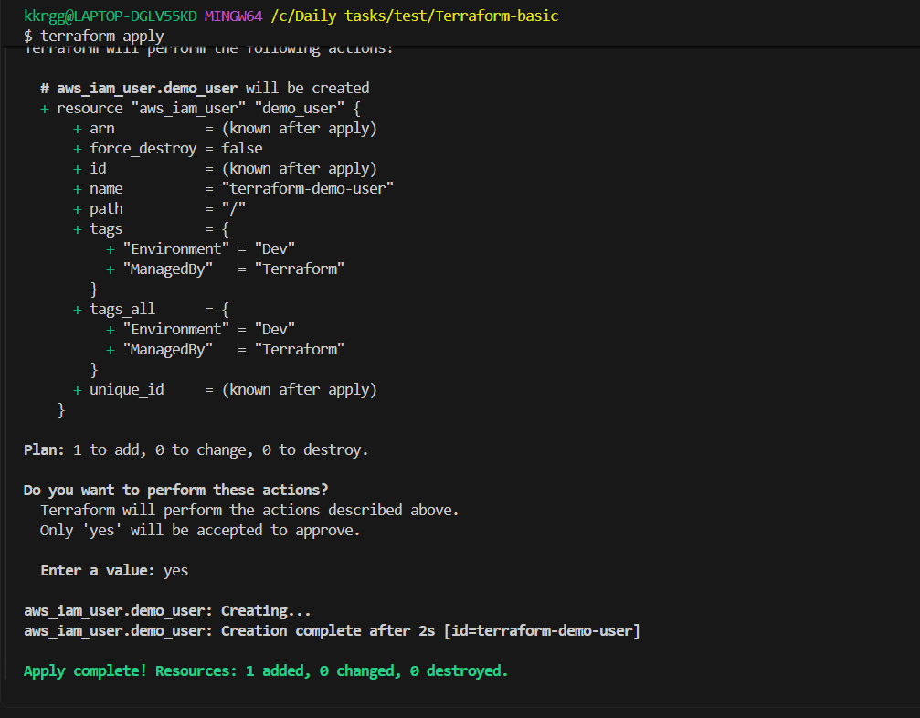
You should see:
Apply complete! Resources: 1 added, 0 changed, 0 destroyed.
Now go to:
AWS Console → IAM → Users
You should see:
terraform-demo-user

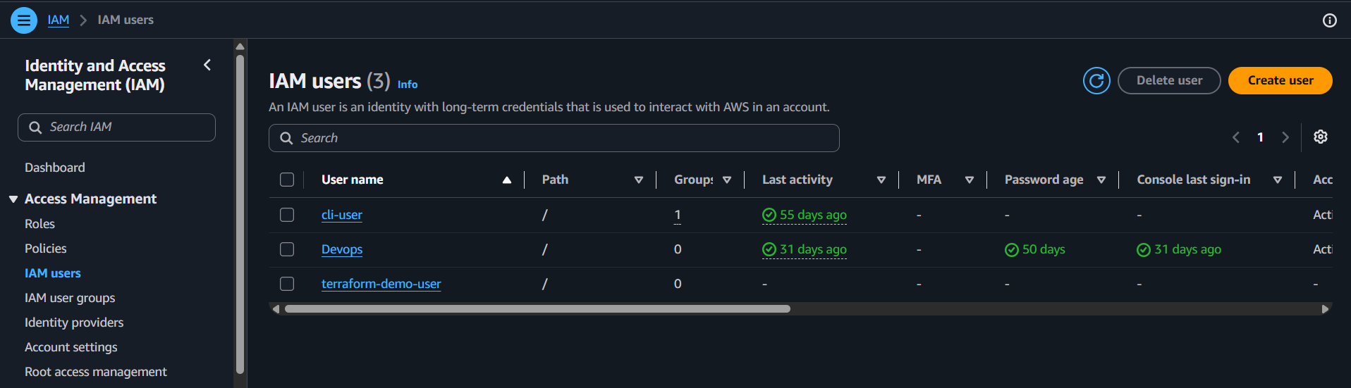
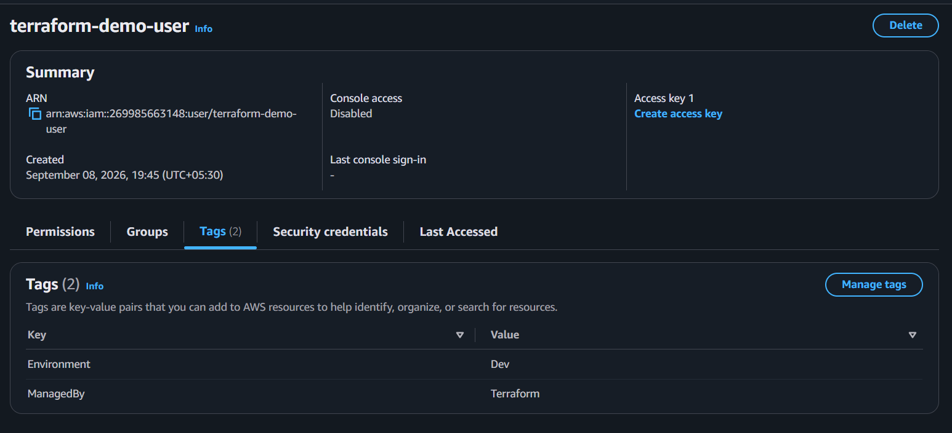

2). Integrate Terraform in Jenkins using the Terraform plugin.

Objective
The objective is to configure Jenkins so that Jenkins can execute Terraform commands automatically:
GitHub
↓
Jenkins
↓
Terraform Plugin
↓
terraform init
↓
terraform validate
↓
terraform plan
↓
terraform apply
↓
AWS Infrastructure
Since we already have Terraform installed on your Jenkins/EC2 environment, we'll focus on the Jenkins Terraform plugin integration.

Step 1 — Prepare Terraform project
Create a project directory:
mkdir terraform-jenkins
cd terraform-jenkins
Create:
terraform-jenkins/
├── main.tf
└── variables.tf
For a simple test, you can use a Terraform resource such as local_file.

main.tf
terraform {
required_providers {
local = {
source = "hashicorp/local"
version = "~> 2.5"
}
}

required_version = ">= 1.0"
}

provider "local" {}

resource "local_file" "example" {
filename = "${path.module}/jenkins-demo.txt"
content = "Terraform executed successfully from Jenkins!"
}
This is a good first test because it doesn't require AWS permissions.

Step 2 — Test Terraform manually first
This is important.
Go inside the Terraform project directory:
cd terraform-jenkins
Run:
terraform init
Then:
terraform validate
Then:
terraform plan
Finally:
terraform apply -auto-approve
You should see something like:
Apply complete! Resources: 1 added, 0 changed, 0 destroyed.
Check:
ls
You should have:
main.tf
jenkins-demo.txt
This confirms your Terraform code itself works before introducing Jenkins.

Step 3 — Push the Terraform project to GitHub
Inside your project:
git init
git add .
git commit -m "Add Terraform Jenkins integration"
Add your GitHub repository:
git remote add origin <YOUR_GITHUB_REPOSITORY>
Then:
git branch -M main
git push -u origin main
Your repository should contain:
terraform-jenkins/
│
├── main.tf
└── variables.tf

Step 4 — Install Terraform Plugin in Jenkins
Open Jenkins:
Jenkins
↓
Manage Jenkins
↓
Plugins
↓
Available plugins
Search:
Terraform
Install the Terraform plugin.
If Jenkins asks for a restart, restart Jenkins after installation.
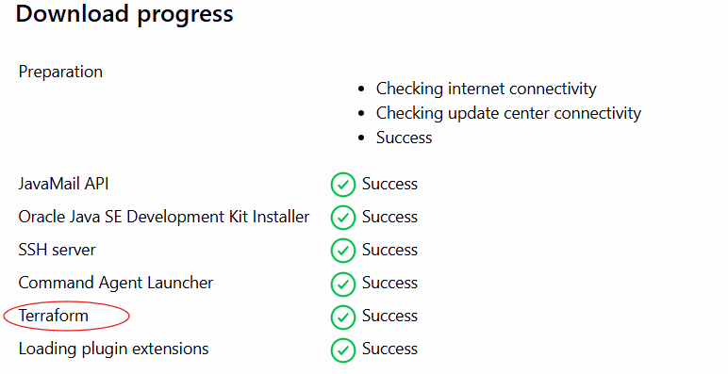

Step 5 — Configure Terraform in Jenkins
Go to:
Manage Jenkins
↓
Tools
Look for:
Terraform installations
Click:
Add Terraform
Give it a name:
Terraform
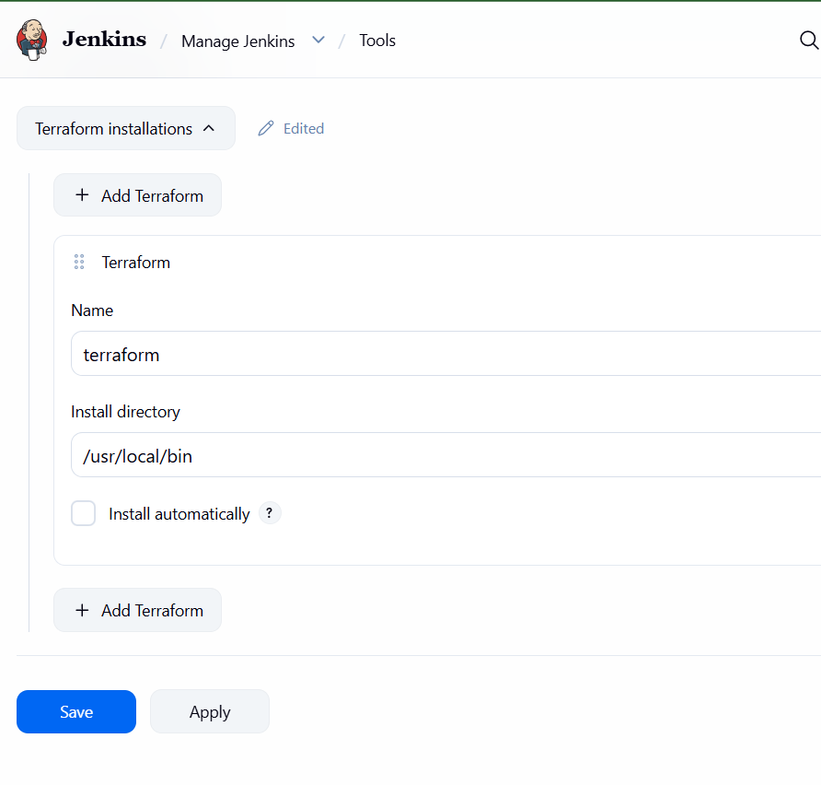

Step 6 — Create Jenkins Pipeline
Go to:
Jenkins
↓
New Item
Enter:
terraform-jenkins
Select:
Pipeline
Click OK.
Scroll to:
Pipeline
Choose:
Pipeline script
Use:
pipeline {
agent any

tools {
terraform 'terraform'
}

stages {

stage('Checkout') {
steps {
git branch: 'main',
url: 'https://github.com/YOUR_USERNAME/YOUR_REPOSITORY.git'
}
}

stage('Terraform Init') {
steps {
sh 'terraform init'
}
}

stage('Terraform Validate') {
steps {
sh 'terraform validate'
}
}

stage('Terraform Plan') {
steps {
sh 'terraform plan'
}
}

stage('Terraform Apply') {
steps {
sh 'terraform apply -auto-approve'
}
}
}
}
Replace:
YOUR_USERNAME
YOUR_REPOSITORY
with your actual GitHub repository.
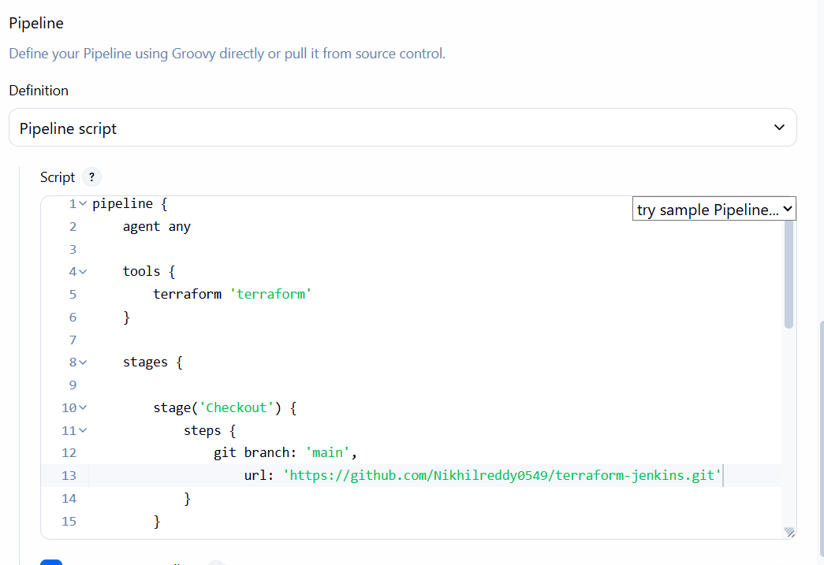

Step 7 — Build the Jenkins job
Click:
Build Now
Jenkins will execute:
Stage 1
Checkout
↓
GitHub repository

Stage 2
Terraform Init
↓
terraform init

Stage 3
Terraform Validate
↓
terraform validate

Stage 4
Terraform Plan
↓
terraform plan

Stage 5
Terraform Apply
↓
terraform apply -auto-approve

Step 8 — Check Console Output
Click the build:
Build #1
↓
Console Output
You should see:
Terraform has been successfully initialized!
Then:
Success! The configuration is valid.
Then the plan:
Plan: 1 to add, 0 to change, 0 to destroy.
Finally:
Apply complete! Resources: 1 added, 0 changed, 0 destroyed.
Your Jenkins build should finish:
Finished: SUCCESS
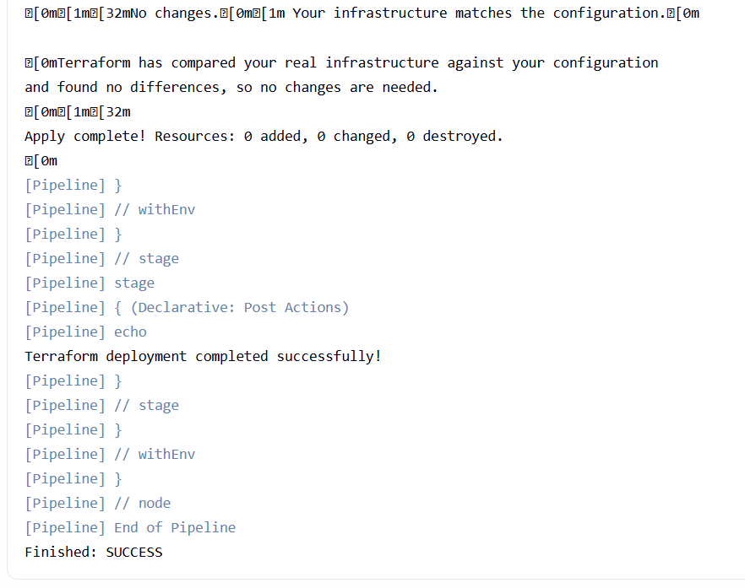
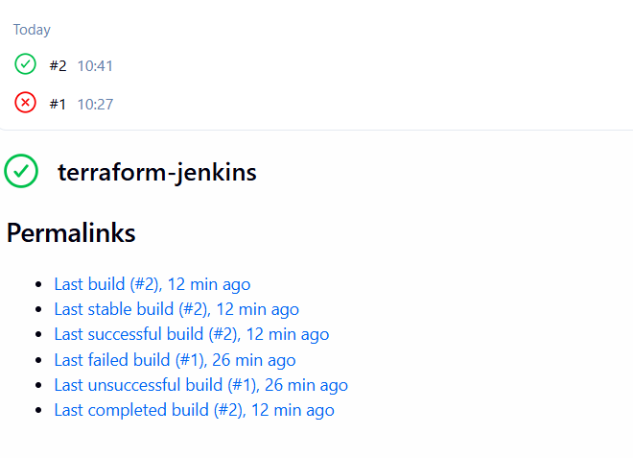

3). Create a CI/CD pipeline for a Nodejs Application: https://github.com/betawins/Trading-UI.git

Objective
Create a Jenkins CI/CD pipeline that automatically:
- Clones the Trading-UI repository.
- Installs Node.js dependencies.
- Runs tests.
- Builds the React application.
- Deploys the generated build/ directory to an EC2 server.
- Runs the application using PM2.

STEP 1 — Prepare the Jenkins server
First, connect to the EC2 instance where Jenkins is installed.
You should be at something like:
[ec2-user@ip-xxx-xxx-xxx-xxx ~]$

1.1 Check Java
Run:
java -version
You should get something similar to:
openjdk version "21..."
Since your Jenkins setup already uses Java 21, this should be fine.

1.2 Check Git
Run:
git --version
Expected:
git version ...
If Git is missing:
sudo dnf install -y git
Then:
git --version

STEP 2 — Install Node.js and npm
Our application is a React/Node-based application, so Jenkins needs Node.js and npm.
Check first:
node -v
and:
npm -v

If both work
For example:
v22.x.x
10.x.x
then don't install them again.

If Node.js is missing
On Amazon Linux, you can install:
sudo dnf install -y nodejs npm
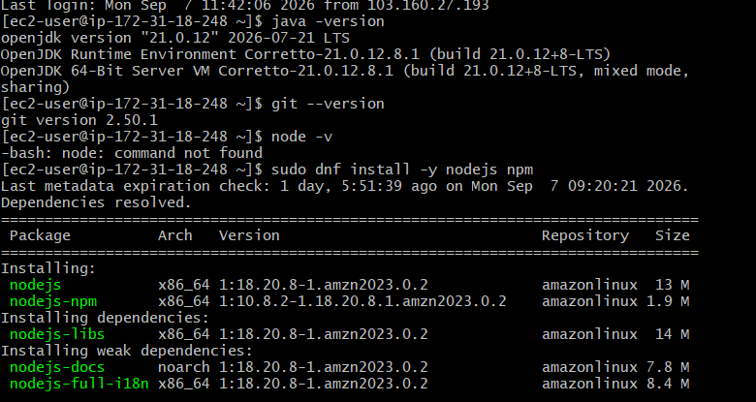
Then verify:
node -v
npm -v
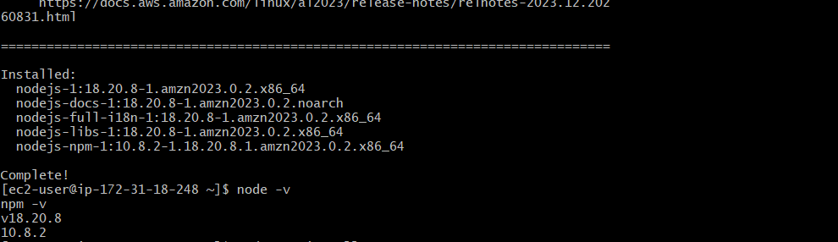

STEP 3 — Install PM2
We will initially deploy the React build/ directory using PM2.
Install:
sudo npm install -g pm2
Check:
pm2 -v
You should get a version number.
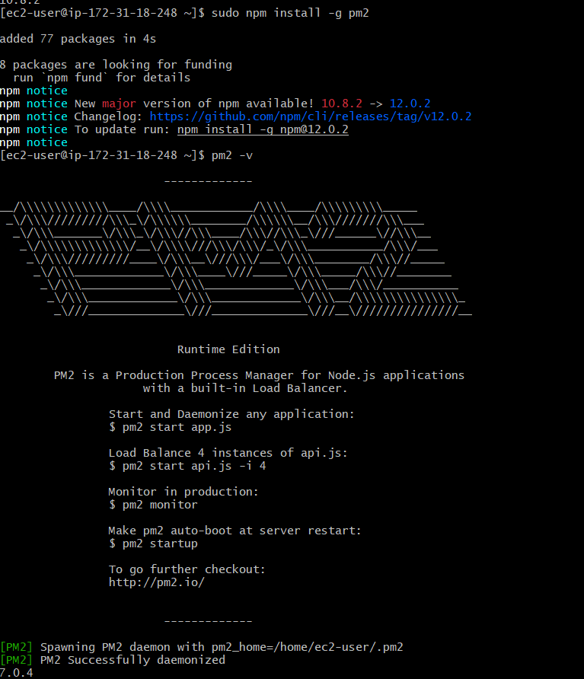

STEP 4 — Check Jenkins user
This is important.
Jenkins normally runs as the jenkins Linux user.
Run:
ps -ef | grep jenkins
You should see something similar to:
jenkins ... java ... jenkins.war
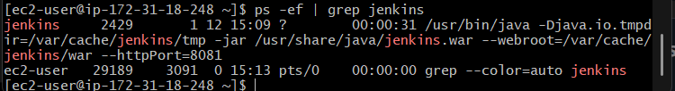
Now check whether Jenkins can access Node:
sudo -u jenkins node -v
Then:
sudo -u jenkins npm -v
And:
sudo -u jenkins pm2 -v
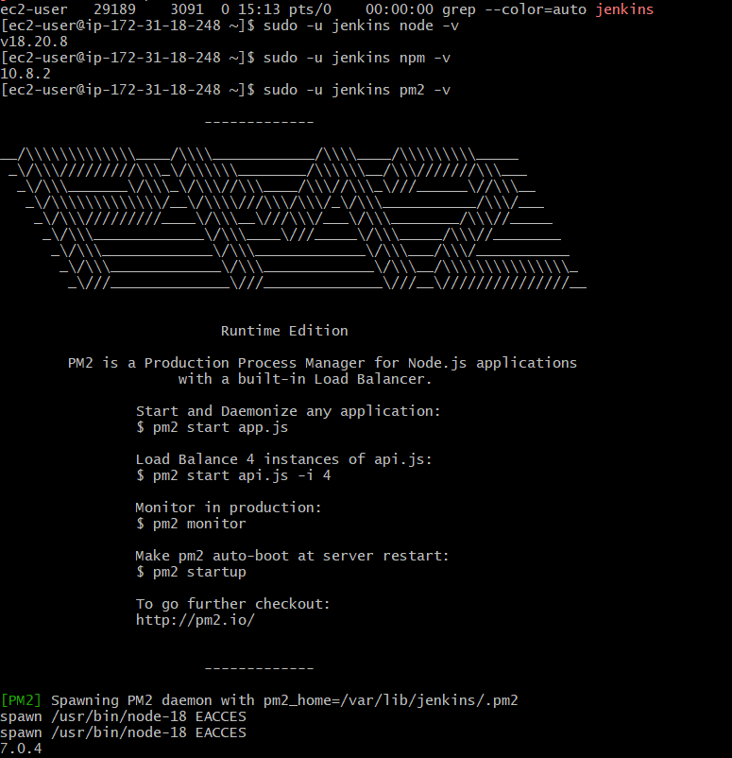

Why are we checking this?
Because this is a very common problem:
Your terminal:
node -v → works

Jenkins:
node -v → command not found
Your normal ec2-user environment and the Jenkins user's environment can be different.
So we need to make sure Jenkins itself can run:
node
npm
pm2

STEP 5 — Check GitHub access
From the Jenkins server, run:
git ls-remote https://github.com/betawins/Trading-UI.git
Because the repository is public, you should get Git references such as:
<commit-hash> HEAD
<commit-hash> refs/heads/master
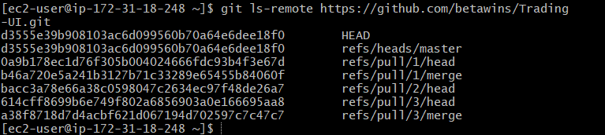
This confirms Jenkins can reach the repository.
We are only reading/cloning the repository. We are not modifying it.

STEP 6 — Create Jenkins Pipeline Job
Now open Jenkins in your browser.
Go to:
Jenkins Dashboard
↓
New Item
Enter:
Trading-UI-Pipeline
Select:
Pipeline
Then click:
OK

STEP 7 — Configure the Pipeline
Scroll down to the Pipeline section.
You will see:
Definition
Select:
Pipeline script
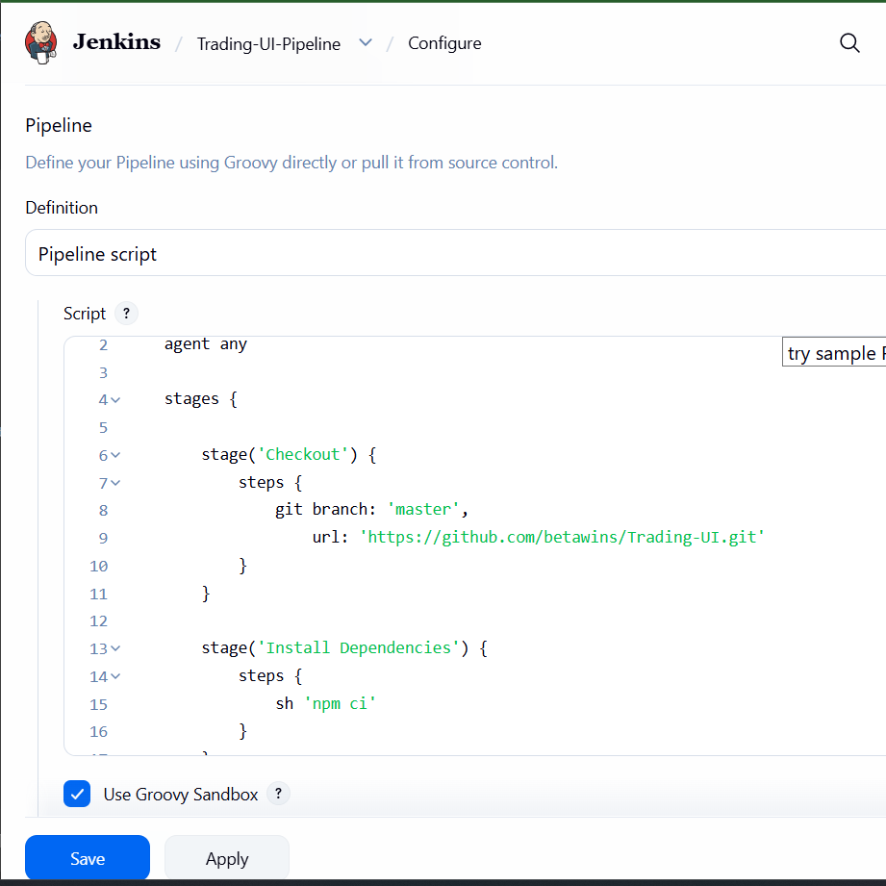

STEP 8 — Paste the Pipeline
In the Script box, paste this:
pipeline {
agent any

stages {

stage('Checkout') {
steps {
git branch: 'master',
url: 'https://github.com/betawins/Trading-UI.git'
}
}

stage('Install Dependencies') {
steps {
sh ' npm install --legacy-peer-deps'
}
}

stage('Test') {
steps {
catchError(buildResult: 'SUCCESS', stageResult: 'UNSTABLE') {
sh 'CI=true npm test -- --watchAll=false'
}
}
}

stage('Build') {
steps {
sh 'npm run build'
}
}

stage('Deploy') {
steps {
sh '''
pm2 delete Trading-UI || true
pm2 serve build 3000 --name Trading-UI --spa
pm2 save
'''
}
}
}

post {
success {
echo 'Trading-UI deployment successful!'
}

failure {
echo 'Trading-UI deployment failed!'
}
}
}
Then click:
Save

STEP 9 — Run the Pipeline
Go to:
Trading-UI-Pipeline
Click:
Build Now
Jenkins should execute:
Checkout
↓
Install Dependencies
↓
Test
↓
Build
↓
Deploy

STEP 10 — Watch Console Output
Click:
Build #1
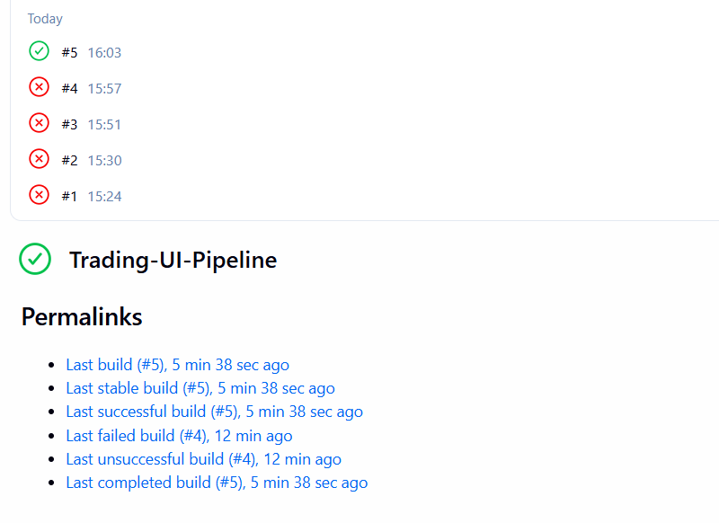
Then:
Console Output
We want to see whether each stage succeeds.
Ideally:
[Pipeline] stage
[Pipeline] { (Checkout)
...
[Pipeline] }

[Pipeline] stage
[Pipeline] { (Install Dependencies)
...
[Pipeline] }

[Pipeline] stage
[Pipeline] { (Test)
...
[Pipeline] }

[Pipeline] stage
[Pipeline] { (Build)
...
[Pipeline] }

[Pipeline] stage
[Pipeline] { (Deploy)
...
[Pipeline] }

Trading-UI deployment successful!
Finished: SUCCESS
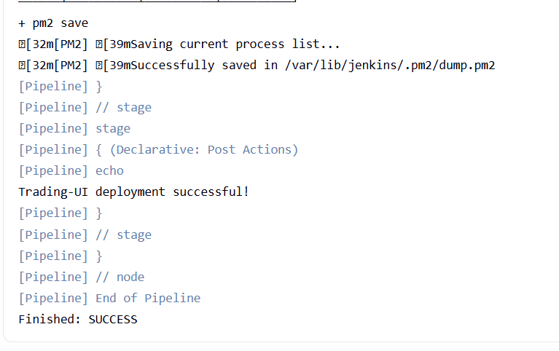

4). Explain 10 Maven commands.

Objective
To understand and practice the 10 commonly used Maven commands used for building, testing, packaging, and managing Java applications.

1. mvn --version

Purpose
Displays the installed Maven version and Java information.
mvn --version
Example output:
Apache Maven 3.8.4
Java version: 17
OS: Linux

When to use
To verify that Maven is installed and check which Java version Maven is using.

2. mvn validate

Purpose
Checks whether the Maven project is correctly configured.
mvn validate
It checks things such as:
- pom.xml configuration
- Project structure
- Required information

Simple meaning
Validate = Check whether the project configuration is valid.

3. mvn compile

Purpose
Compiles the Java source code.
mvn compile
Maven takes:
src/main/java
↓
Java compiler
↓
target/classes

Simple meaning
Compile = Convert Java source code into .class files.

4. mvn test

Purpose
Runs the unit tests.
mvn test
Maven:
Compile source code
↓
Compile test code
↓
Run unit tests

Simple meaning
Test = Run the application's automated tests.

5. mvn package

Purpose
Packages the application into a distributable file such as:
.jar
.war
Command:
mvn package
For example:
src/main/java
↓
compile
↓
test
↓
package
↓
target/myapp.jar

Simple meaning
Package = Create the application's JAR/WAR file.

6. mvn clean

Purpose
Deletes the previous build output.
mvn clean
It normally deletes:
target/
For example:
target/
├── classes/
├── test-classes/
└── myapp.jar
After:
mvn clean
the target directory is removed.

Simple meaning
Clean = Remove previous build files.

7. mvn install

Purpose
Builds the project and installs the generated artifact into the local Maven repository.
mvn install
The local repository is usually:
~/.m2/repository/
For example:
Maven project
↓
compile
↓
test
↓
package
↓
install
↓
~/.m2/repository

Simple meaning
Install = Build the application and store the artifact in the local Maven repository.

8. mvn deploy

Purpose
Uploads the packaged application to a remote Maven repository such as Nexus or Artifactory.
mvn deploy
Typical flow:
Source Code
↓
Compile
↓
Test
↓
Package
↓
Install
↓
Remote Repository
↓
Nexus / Artifactory

Simple meaning
Deploy = Upload the Maven artifact to a remote repository.

9. mvn dependency:tree

Purpose
Displays the project's dependencies and their relationships.
mvn dependency:tree
Example:
com.example:myapp
├── spring-core
├── spring-web
└── mysql-connector
This is particularly useful for finding transitive dependencies and dependency conflicts.

Simple meaning
Dependency tree = Show which libraries your application depends on.

10. mvn clean install
This combines two Maven lifecycle commands:
mvn clean install
First:
clean
↓
Remove target/
Then:
install
↓
Compile
↓
Test
↓
Package
↓
Install artifact into ~/.m2/repository

Simple meaning
Clean install = Remove the old build and create a fresh build, then install the artifact locally.

Important Maven Lifecycle
It's useful to remember this sequence:
validate
↓
compile
↓
test
↓
package
↓
verify
↓
install
↓
deploy

Objective
To create a Jenkins Pipeline that executes and demonstrates 10 commonly used Maven commands.

Jenkinsfile

pipeline {
agent any

stages {

stage('Git Clone') {
steps {
git branch: 'main',
url: 'https://github.com/Nikhilreddy0549/sample.git'
}
}

stage('Maven Version') {
steps {
sh 'mvn --version'
}
}

stage('Validate') {
steps {
sh 'mvn validate'
}
}

stage('Compile') {
steps {
sh 'mvn compile'
}
}

stage('Test') {
steps {
sh 'mvn test'
}
}

stage('Package') {
steps {
sh 'mvn package'
}
}

stage('Clean') {
steps {
sh 'mvn clean'
}
}

stage('Install') {
steps {
sh 'mvn install'
}
}

stage('Dependency Tree') {
steps {
sh 'mvn dependency:tree'
}
}

stage('Clean Install') {
steps {
sh 'mvn clean install'
}
}

stage('Deploy') {
steps {
sh 'mvn deploy'
}
}
}
}
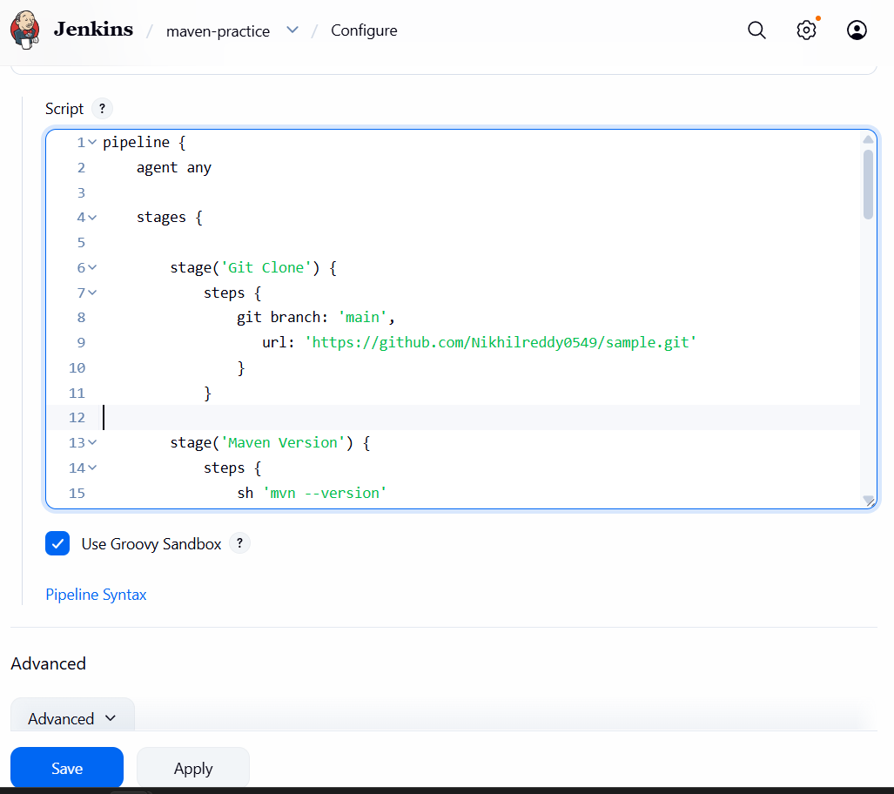
Click save
Click on Build now
